8/9/2022

Internship Report

SAR Utilization Report

**Interns:**

Thiagarajan, Shreya

Khunte, Soham

**Mentors:**

Soundhararajapandian Prabhakaran, Ananth

S, Harishkumar

Contents

1. Introduction 2

2. Problem Statement 3

3. Application Framework 3

4. Data Flow 4

5. Architecture 5

6. Solution 5

7. Application Screenshots 6

8. References 6

# Introduction

The sysstat package includes the sar command, also known as System Activity Reporter. A variety of statistical data are recorded, including CPU load, memory paging, memory utilization, swap usage, network I/O, and much more. It makes this information available in both historical reports and real-time snapshots that show you what is currently taking place on the computer.

Cron command line utility is a job scheduler for Unix-like operating systems. Users who set up and maintain software environments use cron to schedule jobs (also called cron jobs) to run periodically at fixed times, dates, or intervals.

A cron is set up to run every ten minutes by default in the directory /etc/cron.d/sysstat. The purpose is to write a log in the directory /var/log/sa. In this directory there are two types of files starting with sa and sar. SAR is the text file while SA is a binary. The sa file – Binary is updated every 10 minutes whereas the sar file is written at the end of the day.

The files are overwritten once a month to prevent them from gradually consuming the space.

Viewing trends and evolutions is more complex in text mode.

Understanding and spotting patterns and trends in the sar data requires the use of graphic visual representations of information. Large amounts of data can be quickly analyzed using a graphical representation, which makes it possible to make predictions and well-informed decisions.

# Problem Statement

To build a user interface with server performance charts to easily analyze and recognize patterns and trends in CPU load, memory paging, memory utilization, swap usage, network I/O Statistics.

# Application Framework

Sar Report application is developed on Django Framework. Django is a High-level, free and open-source, Python-based web framework that follows the model–template–views architectural pattern.

Models help in interacting with databases. This is the data access layer that processes the data. A template is a presentation layer that completely handles the user interface part. Views are used to execute business logic, interact with models to transfer data, and render templates.

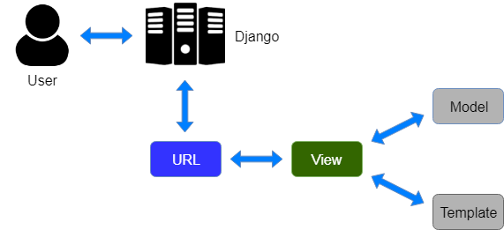

When a user requests a resource from Django, Django acts as a controller and checks the URL for available resources. For URL maps, views that manipulate models and templates are called to render the template. Django responds to the user and sends the template in response.

# Data Flow

The Daily data generated everyday is combined to form a monthly data file which contains data in the format of list of lists. The monthly data file is parsed using a python script and converted to Dictionary format.

* Monthly files = [ [Day1 Statistics], [Day2 Statistics], … ]
* Dictionary Data = { Day1: [ [time, value], [time, value] …]

Day2: [ [time, value], [time, value] …]

…}

* Time Series Data (for the requested day) =

[[Time Stamp, value], [Time Stamp, value], …]

# Architecture

The Website is a single page Application built using Ajax jQuery. A single-page application (SPA) is a web application or website that interacts with the user by dynamically rewriting the current web page with new data from the web server, instead of the default method of a web browser loading entire new pages. The goal is faster transitions that make the website feel more like a native app.

In a SPA, a page refresh never occurs. All necessary HTML, JavaScript, and CSS code is either retrieved by the browser with a single page load, or the appropriate resources are dynamically loaded and added to the page as necessary, usually in response to user actions.

Ajax is a set of web development techniques that uses various web technologies on the client-side to create asynchronous web applications. With Ajax, web applications can send and retrieve data from a server asynchronously (in the background) without interfering with the display and behavior of the existing page. By decoupling the data interchange layer from the presentation layer, Ajax allows web pages and, by extension, web applications, to change content dynamically without the need to reload the entire page.

# Solution

User can enter the server’s name and press Fetch Data Button. This creates an Ajax request to the fetch all data available for that server. This fetched data is formatted into dictionary format. Once data is fetched, the dates for which server’s data is available will be reflected on the date picker. User can choose the date for which charts are to be generated. The timeseries data for that day is extracted from the dictionary and the charts are generated using HighCharts.

Alternatively, User can upload the sa file on the website for a particular day. The binary file is converted to text format and further processed to covert to timeseries data from which the charts are generated.

# Application Screenshots

# References

1. <https://en.wikipedia.org/wiki/Sar_%28Unix%29>
2. <https://tunnelix.com/sar-command-daily-tips-and-tricks/>
3. <https://www.javatpoint.com/django-mvt>
4. <https://en.wikipedia.org/wiki/Single-page_application>
5. <https://en.wikipedia.org/wiki/Ajax_(programming)>